Indoor localization with aircraft signals
Gustiuc Vitalii
341 C5
Vitalii.Gushtiuk@gmaail.com

Introduction
The standard method for outdoor localization is GPS, because it is globally available, relatively accurate and receivers are inexpensive However, GPS also has a major drawback — its satellite signals cannot be received indoors. The problem with GPS is that satellite gets its energy from a
dual solar array, which (depending on the generation of the satellite) generates about 400-2900 W of power^3 about the consumption
of a GSM base station. With an altitude of about 20,000 km, this relatively weak signal barely makes it to earth. In contrast, airplanes and other aircraft are flying at an altitude below 13.7 km and also have ample power. For safety reasons, airplanes and helicopters repeatedly transmit
their location, pretty much like GPS satellites. These so-called ADSB signals are strong enough to be received indoors.

Aircraft Signals
The basic idea behind aircraft signals localization is installing receivers in known positions. A single receiver is enough to serve a large metropolitan area or even a small country. These receivers will calibrate the received aircraft messages, so that any mobile receiver can deduce its position without any additional infrastructure.
More formally, localization system consists of:
• Network of receivers with known positions, which is called ground stations
• Receiver whose position should be determined referred as the handset
• Server, which connects the ground stations and the handset
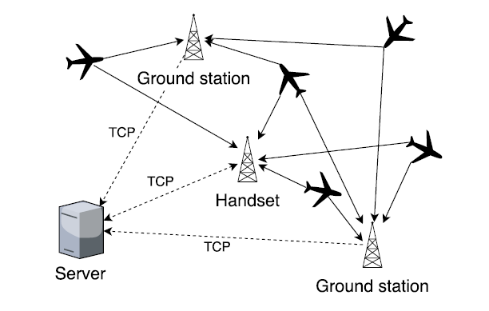
The ground stations receive aircraft signals, decode messages, precisely time their arrival times and send the messages together with the time stamps to the

server. Given enough records for the same message, the server can then determine the message's transmit position and time. To localize a handset, its received messages are also sent to the server like the messages received at the ground stations. The server then matches the handset messages with the corresponding messages from the ground stations for which the transmit position and time are known. The receiver itself consist of a 7 cm long antenna, a USB software-defined radio receiver dongle and a Raspberry Pi 3 board. In future such receivers could be integrated into a smartphone. Signal reception and decoding software is a modified version of the open source project dump1090, 8 which is enhanced with more accurate time resolution.

Related work
Indoor localization based on visible light communication. VLC based indoor localization makes full use of the data transmitted by VLC and the information measured from visible light signals for localization. These data and information include positions of LEDs, positions of other anchors, time stamps, incident angles, and arrival angles etc. There are 3 configurations for VLC localization, directed LOS (line-of-sight), non-directed LOS and diffuse configuration. The difference between these 3 configurations is in the way transmitter and receivers are located.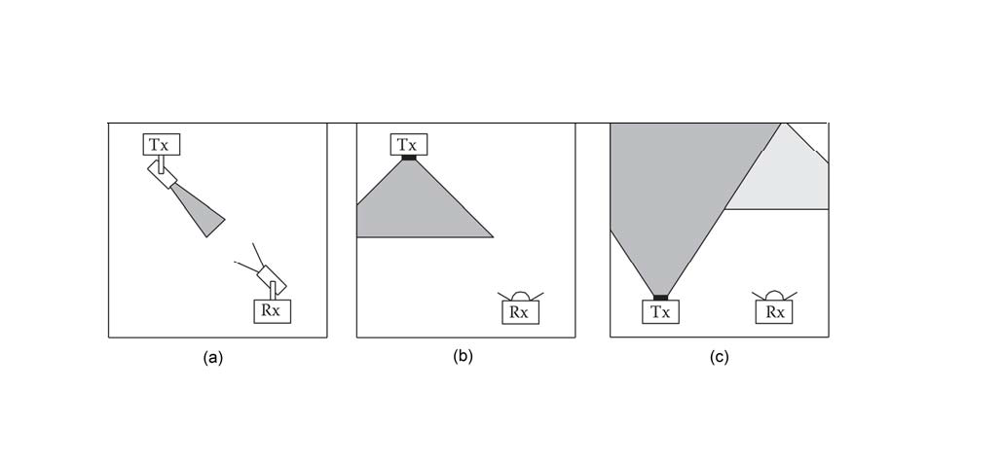
Directed LOS requires low optical power for the transmitter, but can offer the highest data rate given the same transmitted power and the same distance between the transmitter and receiver.
Non-directed LOS configuration can offer a broad signal coverage area by using wide beam transmitters and wide field-of-view (FOV) optical receivers and requires high transmitted power.
In the diffuse configuration, a transmitter points directly towards the ceiling and gives off a wide light beam.

Bluetooth localization. Bluetooth is similar to Wi-Fi in that both systems, share the 2.4 GHz frequency band. This method can give faster response times for identifying base stations. Due to the protocol specifications, Bluetooth devices have to be paired before user data can be exchanged. By using publicly announced device names and received signal strengths of Bluetooth beacons is enough to achieve a localization error of less than 3 meters. Using Neural Networks can achieve sub-meter accuracy. Accuracy using trilateration can be even better with an error less than 0.5 m.

Sensor Fusion. This is a sensor assisted method which is particularly favored in smartphone applications. It uses measurement devices such as accelerometer, a gyroscope and a compass to locate an object. This method works well in combination with other localization system.

Localization based on GSM fingerprinting. This method uses Radio Fingerprint as an unique location for the object. Localization process runs under the assumption that each position or location inside a building has a unique RF signature. The process is composed of two phases: a phase of data collection called off-line phase and a phase of locating a user in real-time called on-line phase. In first phase data is collected from objects and fed to pattern matching machine. In second phase based on input data MLP (Multilayer Perception) network , which uses a supervised error-based learning mechanism outputs result. The error of GSM localization with fingerprinting is ~8m.

Localization wifi-based approach
This method uses Wireless access points to find relationship of received signal strength (RSS) and human position. When a user collects Wi-Fi signals, RSSs, with wireless fingerprint signals in the database, are used to calculate the distance. Location fingerprinting based positioning systems usually work in two phases:

Calibration phase and positioning phase.
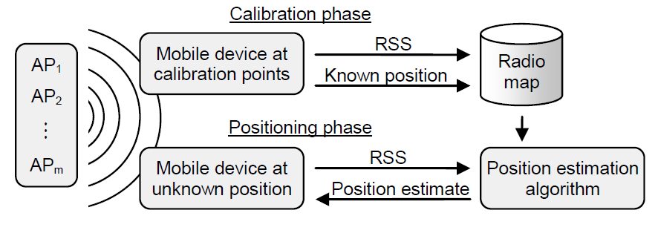
In the calibration phase, a mobile device is used to measure RSS values from several APs at the chosen calibration points in the area of interest. In the positioning phase, a mobile device measures the RSS values in an unknown location and applies a location estimation algorithm to estimate its current location using the previously created radio map. As indoor environments have unique signal propagation characteristics, it can be assumed that each location can be associated with a unique combination of RSS values. The fingerprint position corresponding to the shortest distance is taken as the estimated position of the user. k-nearest neighbor and weighted k-nearest neighbor are two commonly used techniques.

REFERENCES
G. Eason, B. Noble, and I. N. Sneddon, “On certain integrals of Lipschitz-Hankel type involving products of Bessel functions,” Phil. Trans. Roy. Soc. London, vol. A247, pp. 529–551, April 1955.
Parth H. Pathak, Xiaotao Feng, Pengfei Hu, and Prasant Mohapatra. 2015. Visible
Light Communication, Networking, and Sensing: A Survey, Potential and
Challenges. IEEE Communications Surveys & Tutorials 17, 4 (2015), 2047–2077.
Marco Altini, Davide Brunelli, Elisabetta Farella, and Luca Benini. 2010. Bluetooth
Indoor Localization with Multiple Neural Networks. In 5th IEEE International
Symposium on Wireless Pervasive Computing (ISWPC). IEEE, 295–300
Jie Liu, Bodhi Priyantha, Ted Hart, Heitor S. Ramos, Antonio A.F. Loureiro, and
Qiang Wang. 2012. Energy Efficient GPS Sensing with Cloud Offloading. In
Proceedings of the 10th ACM Conference on Embedded Networked Sensor Systems
(SenSys 2012). ACM, 85–98.

High accuracy indoor localization: A WiFi-based approach
Chen Chen , Yan Chen ; Hung-Quoc Lai ; Yi Han ; K.J. Ray Liu

